Home Credit Default Risk Analysis

1 Introduction to the Problem & Data
Problem Statement:
Home Credit Bank aims to assess and improve its loan approval process to balance profitability, fairness, and client satisfaction. The primary goal is to evaluate loan repayment likelihood while addressing biases across demographic groups like age, gender, and family status.

Data Overview:
This dataset includes:
- Dependent Variable: Loan repayment status (binary: 0 - repaid or 1 - defaulted).
- Independent Variables: Demographic attributes (age, gender, family status), financial metrics (income, credit history, etc.), and social characteristics (employment, education, behavior, location, etc.).
- Sensitive attributes like age, gender, and family status are included to assess fairness but may introduce biases.
- Six additional datasets related to application details, credit card balances, previous applications, payment installments, credit bureau information, etc.

Data Preparation:
To ensure that the data was suitable for modeling, we underwent different data cleaning for each model, depending on the requirements of each.
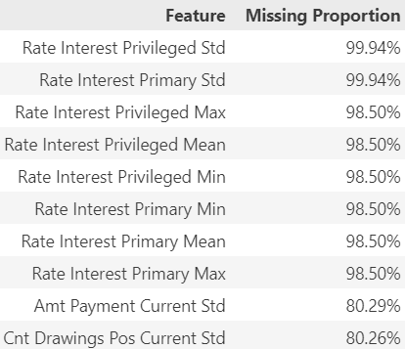
- Merging and Aggregating Data: To ensure a feature-rich starting place for analysis, we began by merging all seven datasets provided to us, collapsing on the primary key and consolidating into a single, comprehensive dataset. Various summary statistics were applied during aggregation to numeric columns, while categorical variables were one-hot-encoded and summed.

- Handling Missing Data: Missing values were filled using median imputation for numerical data and the most frequent value for categorical data to prevent extreme data loss for all models except LGBM, which can handle missing values.

- Normalization: Except for LGBM, numerical features were standardized to ensure that they contributed equally to the model – especially important for models like SVM.
- Feature Selection: To avoid overfitting, we decided to remove irrelevant columns, or select useful features. We selected features by using the feature importance from the LGBM model. The extent of dimensionality reduction was dependent on each model, reflecting their differing ability to handle complex data. Logistic regression was reduced to around 20 features, LDA and SVC to around 100 features, and LGBM to around 500 features.
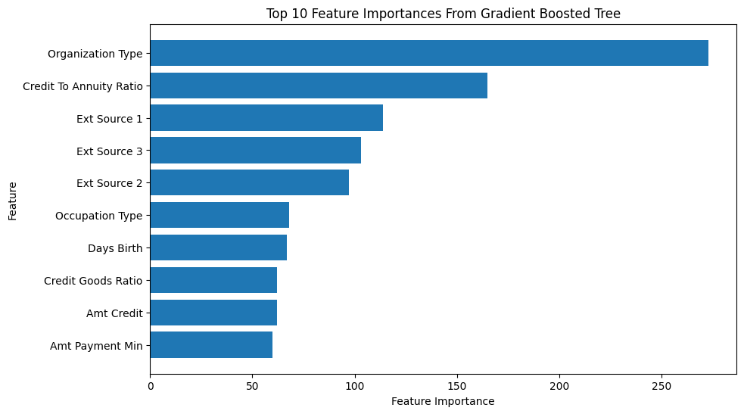
- Feature Engineering:
Created interaction terms (ratio features) to capture more nuanced relationships between financial variables and repayment probability. These interactions were chosen using the most important features from the LGBM model as well as our domain knowledge.

2 Models & Validation Process
Candidate Models
We have developed a predictive model to assess whether mortgage applicants will likely repay their loans. By analyzing historical application data, we implemented four distinct machine-learning models for our analysis:

- Logistic Regression Model
Logistic regression performs well on linearly separable data, but assuming linearity can be a limitation for more complex, non-linear relations, which can be modeled better with flexible models like Support Vector Machines and Gradient Boosted Trees.

- SVM Model
Overall, Linear SVC is a reasonable choice for consideration as it works with our linear separable data and high-dimensional spaces, but it has a very slow training time and is sensitive to outliers in the data.

- LDA Model
LDA is a sound choice as it is quick to train and helps with reducing the feature space. However, it is important to note that it struggles with dealing with outliers and noise.

- LGBM Model
LGBM has benefits with regard to interpretability and fairness, is an efficient model designed for handling complex datasets with missing values, can capture nonlinear relationships between features, and can provide interpretable feature importance scores–critical for interpreting outcomes.

We compared these models to identify the most reliable approach for predicting loan repayment. We not only focus on predicting loan defaults but also ensure a fair and unbiased model that you can use in your decision-making process.

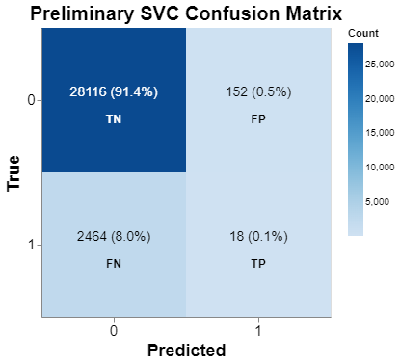
Model Evaluation and Metric Selection Methodology
During preliminary testing, our models appeared to be performing well as they exhibited high accuracy, however, recall was considerably low. This was likely due in part to the class imbalances of the target, as those who did not have difficulty with payments made up about 92% of the data, with only about 8% being defaulters. Our models were consistently underperforming when accurately categorizing this latter category. As misclassifying high-risk borrowers is costly, we decided to prioritize improving the recall of our models to minimize false negatives in our predictions. However, we wanted to avoid increasing false positives, or classifying low-risk borrowers as high-risk, as this would reduce revenue generated from interest payments. Therefore, we decided to strike a balance between precision and recall, settling on F1 as our optimizing metric.

Validation Process
We started with various splitting strategies: a simple randomized 80/20 split, a stratified split on the target variable, and a stratified split across impactful features so that our splits might accurately reflect real-world data. For the last approach, we chose to stratify on age, first creating discrete age groups – young, middle, and old. However, we chose to not proceed with this approach as the performance did not appear to improve significantly. A simple randomized split had its drawbacks as well, as it did not consider the distribution of the target variable. We ultimately chose a relatively simple middle ground and stratified across the target variable to ensure that the proportions in our split sets were reflective of the original data set.

Performing a stratified 90/10 split across the target variable, and reserving a holdout test set for final evaluation, we executed an exhaustive grid search with 5-fold cross-validation to assess our models’ ability to generalize. Beyond model-specific hyperparameters, we additionally tuned for classification threshold, as a lower threshold would increase positive classifications, thereby decreasing false negatives. However, this is not without a tradeoff, as reducing the classification threshold would also increase the number of false positives, highlighting the suitability of F1 as a choice for optimizing metrics when using this approach.

Additional Metrics
Beyond F1 as our optimizing metric, further metrics were considered for comparison of our models’ performance: ROC-AUC for overall performance, precision-recall curve to assess performance for imbalance classes, accuracy, F2, as well as the following fairness metrics: Demographic Parity Ratio, Equalized Odds Ratio, and Equal Opportunity Ratio.

3 Model Comparisons & Final Model Selection
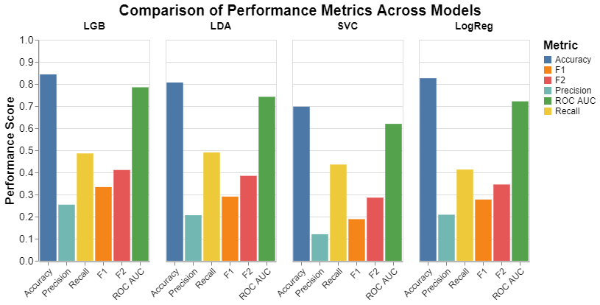

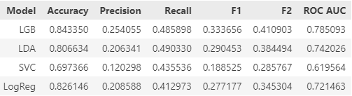
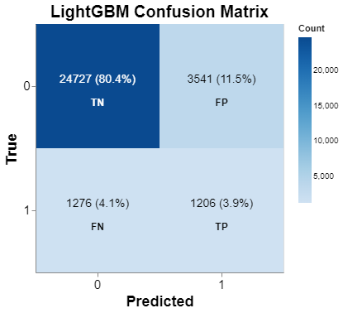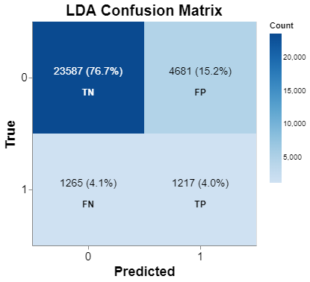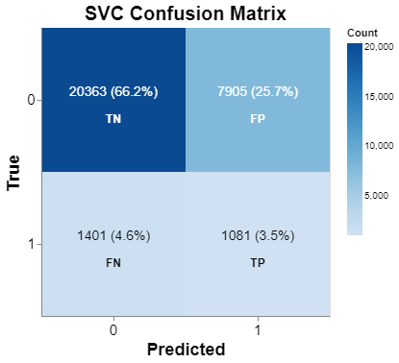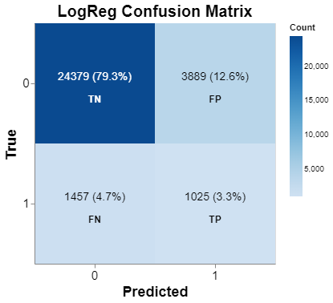
Comparing Model Performance
Accuracy and ROC-AUC all fall within a reasonable range with LGBM performing the best and SVC performing the worst. Recall values are relatively close across all models, with a maximum difference of ~0.05. For precision, LGBM (0.254) is far higher than SVC (0.120), showing that LGBM better avoids false positives. LGBM also scores the best for F1 and F2, while SVC struggles, likely due to poor precision. Overall, LGBM is the clear winner, while LDA and logistics resulted in middle-ground metrics, and SVC performed the worst.
LGBM excels at learning non-linear, complex relationships, possibly making it the top performer. Also, LGBM adjusts better to imbalanced datasets than SVC or linear models. LDA and logistic regression are both similar simpler linear models, so they would perform similarly. SVC may have performed poorly due to a limited hyperparameter space because of SVC’s high computational cost, preventing us from a more exhaustive hyperparameter tuning process.

Final Model – LightGBM
The final model is a Light Gradient Boosted Machine (LGBM), selected for its predictive accuracy compared to the other models. The LGBM model had the best accuracy, precision, F1, F2, and ROC-AUC scores of the four models. The ROC-AUC score of 0.785 indicates reasonable predictive capability, showing the model’s ability to distinguish between positive and negative outcomes.

Model Specifications
- Proportion of features per tree: 0.27
- Minimum samples per leaf: 52
- Maximum leaves per tree: 53
- L2 regularization strength: 10
- Classification threshold: 0.19

The plot below shows an analysis of the training vs validation scores during the boosting iterations of LGBM. As seen by the convergence of the testing error as well the small difference between train and test error, we can be confident that our model is not overfitting the data.
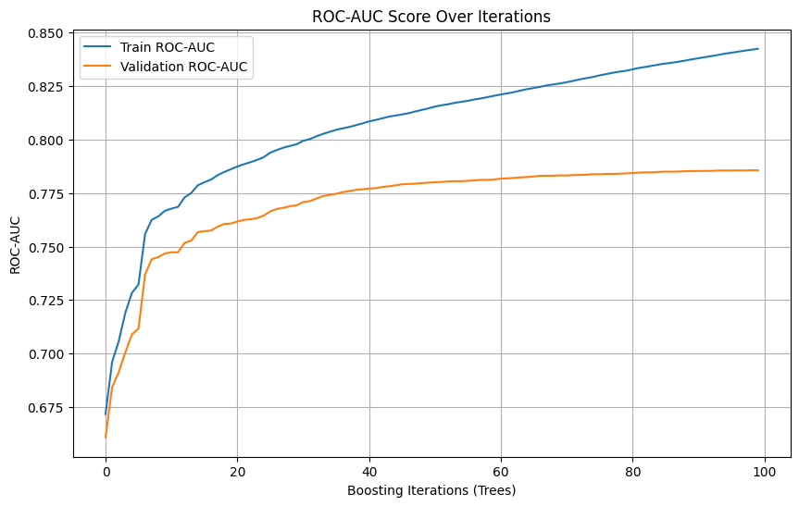

Usage
This model requires a loan application, as well as the applicants previous application history and information. Once inputted into the model, it will return the likelihood that this application will be repaid–or whether or not it should be approved.

Caveats
The apparent absence of granular cost data prevents us from conducting precise evaluation of the cost-benefit tradeoff between utilizing different models. Specifically, the cost of a false negative—predicting repayment for a client who defaults—cannot be fully quantified as the dataset does not appear to specify how much of the loan principal remains unpaid or to what extent losses have been recuperated through collateral or by other means.

With the exclusion of the aforementioned data, the models are primarily evaluated based on classification metrics rather than their direct financial impact to your bank. Therefore, we request additional information regarding monetary losses associated with each customer who had difficulty with payments. The inclusion of this data would allow us to quantify the tradeoffs between misclassifications more accurately, guiding our approach during the model selection process and potentially resulting in a more financially optimal choice for a final model.

4 Ethical Considerations & Recommendations

Ethical Consideration
- Bias in Predictions: The inclusion of sensitive attributes like age and gender can propagate systemic biases, even if indirectly correlated with repayment likelihood.
- Disparate Impact: While optimizing for profitability, disadvantaged groups may face higher rejection rates, even when they could likely repay loans.
- Transparency and Client Trust: Clients may perceive the algorithm as unfair if rejected without clear explanations.

Recommendations:
- Adopt Fair Lending Practices: Commit to fairness by excluding sensitive attributes in decision-making and improving fairness metrics.
- Audit Models Regularly: Continuously monitor fairness and performance metrics to ensure compliance with ethical and regulatory standards.
- Transparency: Provide clear, actionable explanations for loan approval or rejection to maintain client trust.
- Inclusive Products: Develop products tailored to underrepresented groups to offset systemic disadvantages.

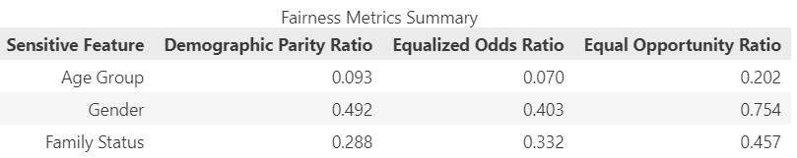

- The Demographic Parity Ratio for Age Group (0.093) and Family Status (0.288) appears lower than Gender (0.492), indicating disparities in outcomes across age groups and family status categories.
- Similarly, Equalized Odds Ratios and Equal Opportunity Ratios show significantly less fairness for Age Groups compared to other feature
- Equalized odds ratio can often be too conservative for models, thus we will focus on the equal opportunity scores.

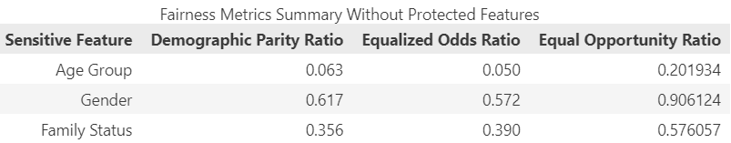

- Excluding protected features improved fairness for Gender and family status. However, fairness for the Age Group worsens slightly.
- Removing these protected classes barely harmed our metrics, the cross-validated ROC-AUC merely decreased from 0.785 to 0.782. Thus, we feel confident that the protected classes can safely be removed to create a fairer model.
- The ratio for gender is quite high, acceptable for a fair model. Family status is alright, however the age group is still very low. However, this could be because age group and family status have many groups, it would be beneficial to check the actual scores.
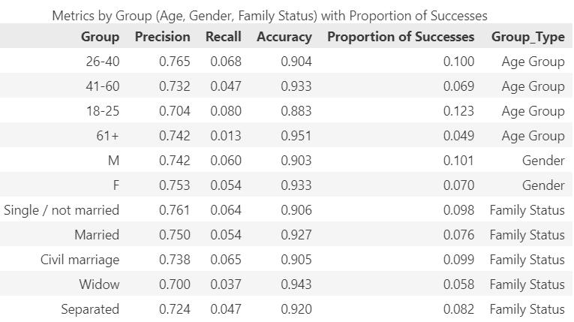
As we can see from the actual precision, recall, and accuracy scores for each group in each protected class, none vary that much. These scores are from the model with protected classes removed. We feel comfortable saying this model fairly predicts each group. As for the proportion of successes predicted for each group by the model, the model still does not vary to an extreme amount, however, these scores could be improved. Additionally, we see that the scarcity of successes from our model in general due to the imbalanced dataset, could be a possibility as to why the ratio scores differ by so much.

- Recommendations:
  - Investigate why age-related disparities exist. Are there systemic biases in the data (e.g. younger applicants have less financial history?)
  - Implement fairness-aware algorithms to mitigate observed bias in model predictions for Age Group and Family Status
  - Use the fair model with the protected classes removed. We believe that it can be used with minimal issues revolving around bias.

5 Takeaway Message to the Client
Key Takeaways
- Loan Approval Strategy: Use the model to predict loan repayment likelihood and prioritize loans with repayment probabilities above a certain threshold (e.g., 70%).
- Flag high-risk applicants for further review: Flagged applicants can undergo a manual review to mitigate financial risk.
- Improve Efficiency with Automation: Integrating the model into loan application workflow to automate the process by automatically approving low-risk loans and denying high risk.
- Leverage Insights: Interpret the model using output such as the feature importance to identify the most important predictors for identifying patterns of high vs. low-risk applicants.
- Optimize loan approval decisions to balance risk: Maximize loan approvals while minimizing the default rates by using and optimizing repayment likelihoods from the model.
- Address Fairness Concerns: Exclude sensitive attributes like age and family status from the model to mitigate biases. Regularly audit fairness metrics and adjust thresholds for underrepresented groups as necessary.
- Operational Improvements: Incorporate recommendations like personalized loan products for different age groups to improve inclusivity and customer satisfaction.

